

Classified Leadership Institute for Professionals

**Manual and Guidelines for Incoming Cohorts**

Revised: March 25, 2019

**Table of Contents**

**Core Values and Background1**

Mission, Vision, Values and Goals2

History of CLIP2

What is CLIP?2

**Key Processes and Program Components4**

Nomination and Selection of Cohort5

Core Program Components5

**Resources4**

Core Program Components5

**Appendix: Document Templates4**

Nomination Form5

Sign-in Sheets5

Meeting Agenda and Minutes5

**Core Values and Background**

**MISSION**

Empower Classified Professionals through the implementation of programs focused on providing professional skills, educational knowledge, and personal growth that supports the goals of our educational community.

**VISION**

Foster a supportive culture that values individuals and cultivates effective leaders to strengthen the educational impact of Chabot - Las Positas Community College District

**GOALS**

Cultivate professional leaders

Encourage community wide involvement

Create networking opportunities

Build a supportive environment Illuminate leadership skills

Recognize outstanding service and dedication

Provide guidance and mentoring support

**ABOUT CLIP**

CLIP was created by Classified Professionals with the strong endorsement of the Chancellor and District-wide Executive Administrators with the intention of building the next generation of Classified Professional Leaders. CLIP is an independent, hands-on educational institute that encourages the pursuit of professional development and networking opportunities. Participants are empowered to identify and pursue activities of interest with the support of an advisor.

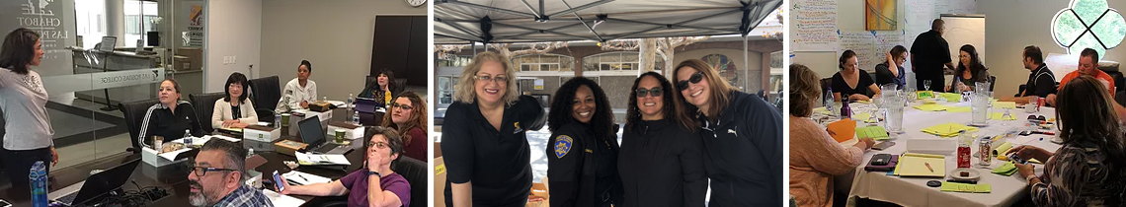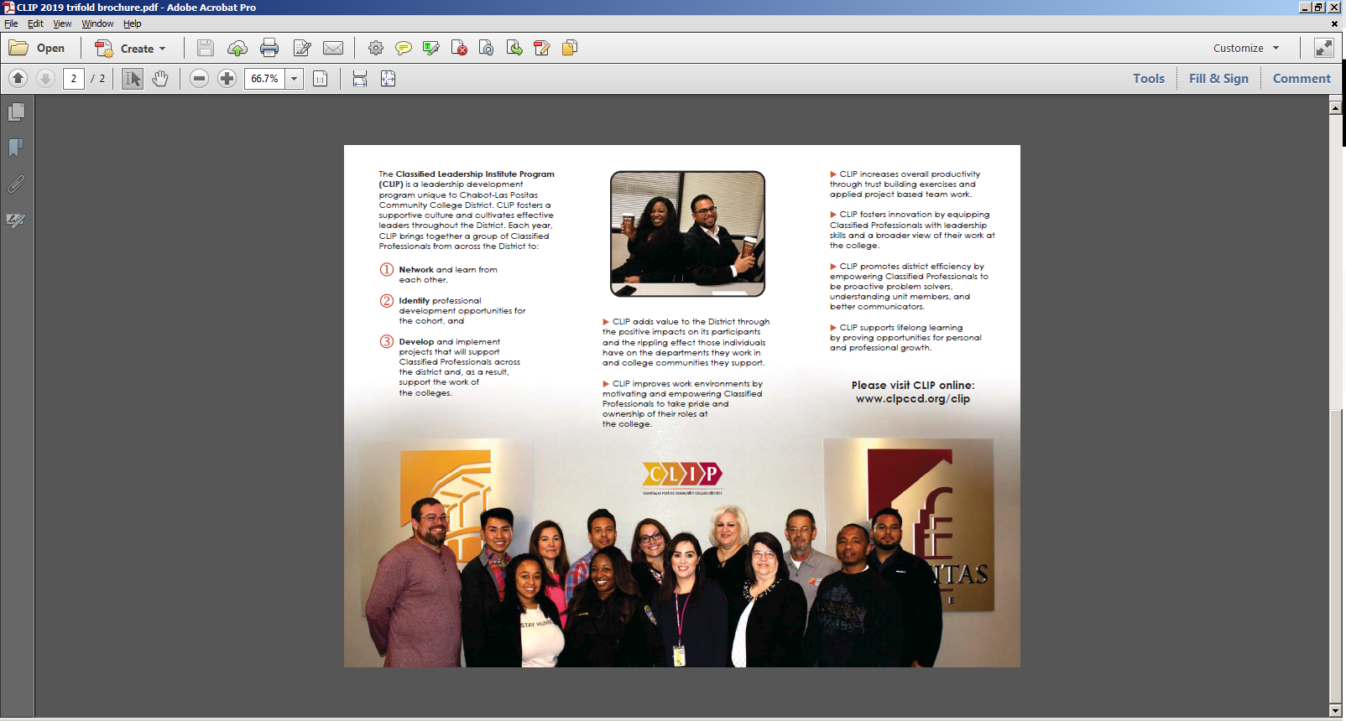**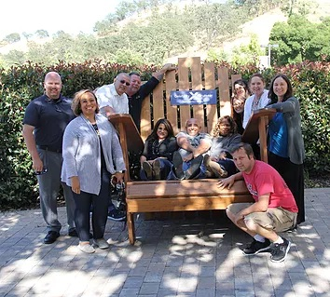History of CLIP (??)**

**What is CLIP?**

The Classified Leadership Institute Program (CLIP) is a leadership development program unique to Chabot-Las Positas Community College District, designed and developed for Classified Professionals. CLIP fosters a supportive culture and cultivates effective leaders throughout the District. Each year, CLIP brings together a group of Classified Professionals from across the District to:

1. Network and learn from each other,
2. Identify professional development opportunities for the cohort, and
3. Develop and implement projects that will support Classified Professionals across the district and, as a result, support the work of the colleges.

CLIP adds value to the District through the positive impacts on its participants and the rippling effect those individuals have on the departments they work in and college communities they support.

* CLIP improves work environments by motivating and empowering Classified Professionals to take pride and ownership of their roles at the college and district
* CLIP increases overall productivity through trust building exercises and applied project based team work
* CLIP fosters innovation by equipping Classified Professionals with leadership skills and a broader view of their work at the college and district
* CLIP promotes district efficiency by empowering Classified Professionals to be proactive problem solvers, understanding unit members, and better communicators.
* CLIP supports lifelong learning by proving opportunities for personal and professional growth

**Key Processes and Program Components**

**CLIP Program Core Structure**

**Program Needs:**

* Meetings at least once a month (minimum 4 hours per meet)
* Funding & Resources

**Participant Selection and Induction:**

* Application to CLIP program through nomination (self/colleague)
* Selection: Participants selected by previous cohort, approved by Chancellor
* Three Day Induction Model (training)

**Program Procedural Basics**

* Agenda
* Sign-in sheets
* Minutes/Notes (work accomplished)
* Key Focus: Leadership Capacity for Building Team Work
* Working Agreement/ group norms

**Meeting Components:**

* Grounding (“Get to know”)
* Think about it
* Write it down
* Share it
* Chart it
* Talk about it

**Nomination and Selection Process**

**Process**

The nomination process should begin by March. The current CLIP cohort opens the nomination process each year by meeting to discuss logistics and review criteria. The current CLIP cohort invites Classified Professionals to apply (self-nominate) or receive nomination from the District community. The current CLIP cohort will determine the selection criteria they will apply to form the new cohort. After the initial nomination period, the current cohort reviews applications for eligibility and ensures appropriate representation from all district areas. If there is a need for additional applicants, the group can extend the nomination process to allow for focused outreach and attempt to meet a suitable composition for the incoming cohort. The goals are to create an opportunity for shared experiences and networking opportunities across the district.

**Timelines**

* March/April – Nominations are opened, initial outreach and selections begin
* May – Final Acceptance Letters and details of participation are sent out
  + Planning for the CLIP Summer Institute for the new cohort
  + Planning of new cohort Orientation with outgoing CLIP members
* New Cohort starts on July 1st of that year

**Eligibility and Selection Criteria**

To be eligible, you must:

* apply or be nominated
* request permission from the person being nominated
* be a regular permanent employee by the time the program begins
* have a desire to develop your personal leadership and professional skills
* notify your direct manager of your participation
* commit a 2-day CLIP Summer Institute, and 4 to 8 hours per month from August through June of your cohort year, plus additional work outside of those hours in support of CLIP activities

The prior cohort, based on application and nomination responses, makes participation decisions for CLIP. An ideal cohort composition is: 1 Confidential, 3 LPC, 3 Chabot, 3 District, 1 M&O, 1 ITS.

The graduating cohort establishes and applies the scoring criteria.

**Professional Culture around Leadership**

Project:

Sustainability- that builds our capacity as leaders to communicate and solve problems.

Team work which encompasses:

* Communication
* Collaboration
* Critical Thinking
* Creativity

Purpose: to be able to work effectively in a system.

Success Indicator: Working together to come together and build bridges between campuses to support connectivity.

**Resources**

**Recommended Resources**

**Key Workshops:**

* Orientation / Team Building Session (2-3 days)
* Personal Branding
* District Budget

**Things to Keep Track of:**

* Professional Pictures
* Group pictures (official and meetings)
* Sign-in sheets, agendas, and minutes for all meetings

**Suggested Things to Discuss:**

* Define ground rules
* Define and assign roles/responsibilities
* Brainstorm and identify professional development/leadership topics of interest to cover throughout year
* Budget and Cohort activities
* Cohort Target Achievements (Goals for the year)
* Brainstorm cohort project ideas
* Work with Advisor to identify topics, presenters, and support

**Appendix**